Non-uniform grid stencils results

This document contains the results and examples of the 1st and 2nd derivative of a function using function values at locations $x_{i}$, $α_{k}$ and $β_{j}$ with respective indexes. Below are diagrams of the possible stencils that may be made from the results of this document. The following analysis is valid for non-uniform grids.

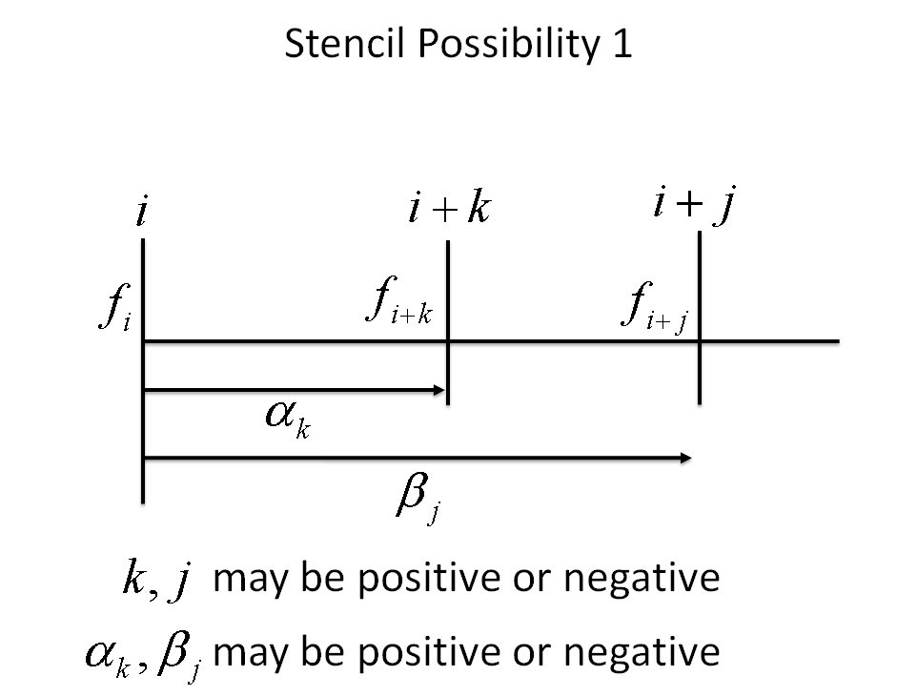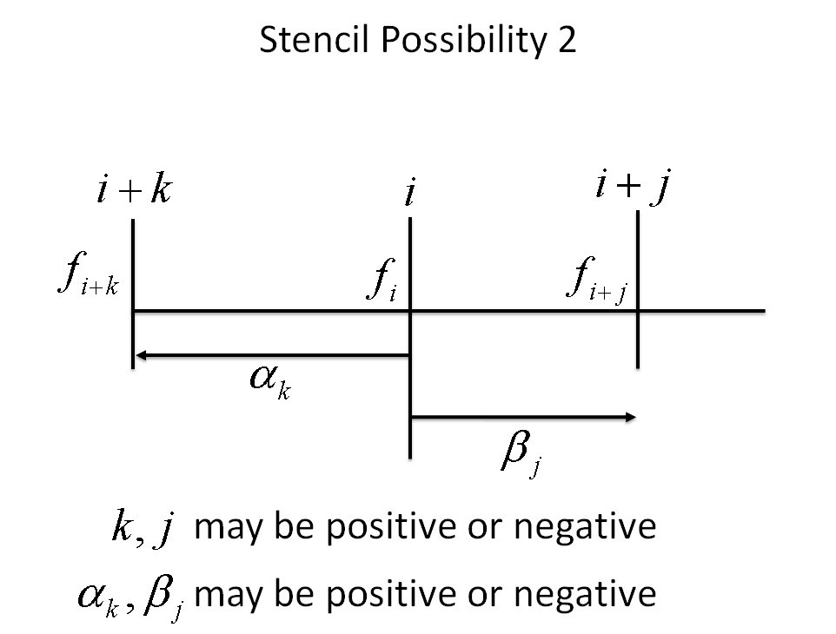

# Results

These results were obtained by solving the following system of equations

$$f_{i+k}=f_{i}+α_{k}f_{i}^{'}+\frac{1}{2}{α_{k}}^{2}f_{i}^{''}+O\left(α_{k}^{3}\right) , f_{i+j}=f_{i}+β_{j}f_{i}^{'}+\frac{1}{2}{β_{j}}^{2}f_{i}^{''}+O\left({β_{j}}^{3}\right)$$

$$f_{i+k}=f_{i}+α_{k}f_{i}^{'}+\frac{1}{2}{α_{k}}^{2}f_{i}^{''}+\frac{1}{3!}{α_{k}}^{3}f_{i}^{'''}+O\left(α_{k}^{4}\right) , f_{i+j}=f_{i}+β_{j}f_{i}^{'}+\frac{1}{2}{β_{j}}^{2}f_{i}^{''}+\frac{1}{3!}{β_{j}}^{3}f_{i}^{'''}+O\left({β_{j}}^{4}\right)$$

## 1st derivative

$$\boxed{f_{i}^{'}=\frac{1}{\left(β_{j}-α_{k}\right)}\left\{f_{i}\left(\frac{α_{k}}{β_{j}}-\frac{β_{j}}{α_{k}}\right)+\frac{β_{j}}{α_{k}}f_{i+k}-\frac{α_{k}}{β_{j}}f_{i+j}\right\}+O\left(α_{k}β_{j}\right)} α_{k}≠β_{j}$$

Solving for $f_{i}$ for BCs

$$\boxed{f_{i}=\frac{\left(f_{i}^{'}\left(β_{j}-α_{k}\right)-\frac{β_{j}}{α_{k}}f_{i+k}+\frac{α_{k}}{β_{j}}f_{i+j}\right)}{\left(\frac{α_{k}}{β_{j}}-\frac{β_{j}}{α_{k}}\right)}+O\left(α_{k}β_{j}\right)} α_{k}≠β_{j}$$

## 2nd derivative

$$\boxed{f_{i}^{''}=\frac{2f_{i}}{α_{k}β_{j}}+\frac{2f_{i+k}}{{α_{k}}^{2}-α_{k}β_{j}}+\frac{2f_{i+j}}{{β_{j}}^{2}-β_{j}α_{k}}+O\left(-β_{j}α_{k}-\left(β_{j}+α_{k}\right)\right)} α_{k}≠β_{j}$$

# Examples - 1st derivative

## Example 1 (central difference)

Let

$$α_{k}=-Δx k=-1$$

$$β_{j}=Δx j=1$$

This results in

$$\frac{β_{j}}{α_{k}}=-1 , β_{j}-α_{k}=2Δx$$

$$f_{i}^{'}=\frac{1}{2Δx}\{f_{i}\left(-1+1\right)-f_{i-1}+f_{i+1}\}$$

$$=\frac{1}{2Δx}(f_{i-1}+f_{i+1})$$

The order of accuracy should be

$$O\left(α_{k}β_{j}\right)=-O\left(ΔxΔx\right)=O(Δx^{2})$$

Which is the 2nd order accurate, first derivative central differencing equation. Note that the indexes $k$ and $j$ should be $-1$ and $1$ respectively.

## Example 2 (forward difference)

Let

$$α_{k}=Δx k=1$$

$$β_{j}=2Δx j=2$$

This results in

$$\frac{β_{j}}{α_{k}}=2 , β_{j}-α_{k}=Δx$$

$$f_{i}^{'}=\frac{1}{Δx}\{f_{i}\left(\frac{1}{2}-2\right)+2f_{i+1}+\frac{1}{2}f_{i+2}\}$$

$$=\frac{1}{2Δx}\left\{-3f_{i}+4f_{i+1}-f_{i+2}\right\}$$

The order of accuracy should be

$$O\left(α_{k}β_{j}\right)=O\left(Δx2Δx\right)=O(Δx^{2})$$

Which is the 2nd order accurate, first derivative forward differencing equation.

# Examples - 2nd derivatives

## Example 1 (central difference)

Let

$$α_{k}=-Δx k=-1$$

$$β_{j}=Δx j=1$$

This results in

$$\frac{β_{j}}{α_{k}}=-1 , β_{j}-α_{k}=2Δx$$

$$f_{i}^{''}=2f_{i}\frac{1}{-Δx^{2}}-2f_{i+k}\frac{1}{{\left(-Δx\right)}^{2}\left\{-2\right\}}+2f_{i+j}\frac{1}{Δx(-Δx)\left\{-2\right\}}$$

$$=\frac{-2f_{i}+f_{i+k }+f_{i+j} }{Δx^{2}}$$

Which is the 2nd order central difference scheme.

## Example 2 (forward difference)

Let

$$α_{k}=Δx k=1$$

$$β_{j}=2Δx j=2$$

This results in

$$\frac{β_{j}}{α_{k}}=2 , β_{j}-α_{k}=Δx$$

$$f_{i}^{''}=\frac{2f_{i}}{Δx2Δx}+\frac{2f_{i+k}}{\left\{{Δx}^{2}-2Δx^{2}\right\}}+\frac{2f_{i+j}}{\left\{{(2Δx)}^{2}-2Δx^{2}\right\}}$$

$$f_{i}^{''}=\frac{f_{i}}{Δx^{2}}-\frac{2f_{i+k}}{{Δx}^{2}}+\frac{f_{i+j}}{{Δx}^{2}}$$

$$f_{i}^{''}=\frac{f_{i}-2f_{i+k}+f_{i+j}}{Δx^{2}}$$

Which is the 2nd order forward difference scheme.

## Example 3 (non-uniform grid)

The diffusive terms may be written as

$$f^{''}=\frac{1}{Δx_{i+\frac{1}{2}}}\left(\frac{f_{i+1}-f_{i}}{Δx_{i+1}}-\frac{f_{i}-f_{i-1}}{Δx_{i}}\right)$$

$$=\frac{2}{Δx_{i+1}+Δx_{i}}\left(\frac{f_{i+1}-f_{i}}{Δx_{i+1}}-\frac{f_{i}-f_{i-1}}{Δx_{i}}\right)$$

Factoring terms

$$=f_{i}\left(\frac{-2}{\left(Δx_{i+1}+Δx_{i}\right)}\left(\frac{1}{Δx_{i+1}}+\frac{1}{Δx_{i}}\right)\right)+f_{i-1}\left(\frac{2}{Δx_{i}\left(Δx_{i+1}+Δx_{i}\right)}\right)+f_{i+1}\left(\frac{2}{Δx_{i+1}\left(Δx_{i+1}+Δx_{i}\right)}\right)$$

First term

$$\frac{-2}{\left(Δx_{i+1}+Δx_{i}\right)}\left(\frac{1}{Δx_{i+1}}+\frac{1}{Δx_{i}}\right)=\frac{-2}{Δx_{i}Δx_{i+1}\left(Δx_{i+1}+Δx_{i}\right)}\left(Δx_{i}+Δx_{i+1}\right)=\frac{-2}{Δx_{i}Δx_{i+1}}$$

Returning

$$f^{''}=2f_{i}\frac{1}{-Δx_{i}Δx_{i+1}}+2f_{i-1}\left(\frac{1}{Δx_{i}\left(Δx_{i+1}+Δx_{i}\right)}\right)+2f_{i+1}\left(\frac{1}{Δx_{i+1}\left(Δx_{i+1}+Δx_{i}\right)}\right)$$

Let

$$α_{k}=-Δx_{i}$$

$$k=-1$$

$$β_{j}=Δx_{i+1}$$

$$j=1$$

Substituting

$$f^{''}=2f_{i}\frac{1}{α_{k}β_{j}}+2f_{i-1}\left(\frac{1}{-α_{k}\left(β_{j}-α_{k}\right)}\right)+2f_{i+1}\left(\frac{1}{β_{j}\left(β_{j}-α_{k}\right)}\right)$$

$$=\frac{2f_{i}}{α_{k}β_{j}}+\frac{2f_{i-1}}{α_{k}^{2}-α_{k}β_{j}}+\frac{2f_{i+1}}{β_{j}^{2}-β_{j}α_{k}}$$

This is the same form of the equation that I've derived.